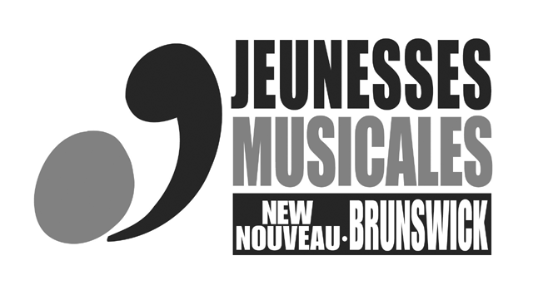
LAETITIA-CYR SCHOLARSHIP FUND

Description
Through the Laetitia-Cyr Scholarship Fund, Jeunesses Musicales New Brunswick offers scholarships of $500 to New Brunswick students who are taking advanced studies in classical music and wish to attend a recognized music camp or master class with a renowned musician or participate in an international or national competition. The registration deadline is May 15, 2015.

Application form

Name: _____________________________ First Name: __________________________
Address: ______________________________________________ Apt: _____________
City: _____________________________________________ Postal code: ___________
Phone: ___________________________ Email: ________________________________
Date of birth: _______________________ Place of birth: _________________________
Submit the following documents:

1. – A complete and up-to-date- curriculum vitae.
2a. - A letter describing your study program and the name and address of the music camp which you wish to attend; proof of registration will have to be provided in order to receive the scholarship.
2b. - A letter from your master class teacher as a proof that you have been accepted.
2c. - If you have applied to an international or national competition, proof of acceptance will have to be provided in order to receive the scholarship.
3. - Proof of New Brunswick residency (birth certificate copy, driver’s licence or Medicare card copy).
4. - A budget specifying your anticipated expenses (registration fees, accommodations, travel, etc.) and other sources of income.

Send all documents by May 15, 2015, by e-mail or by mail to the following address:
Jeunesses Musicales New Brunswick
635 Boudreau Road
Bertrand (N.B.) E1W 1J7
For further information, you can send an e-mail to: jeunesses.musicales@laposte.net

