2014 APPLICATIONS
concert projects for general audiences
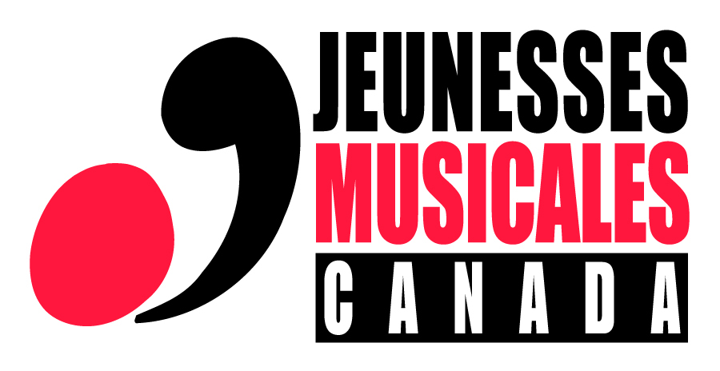
for the 2016-2017 artistic season

Deadline for submission of presentation folder: September 19th, 2014
Jeunesses Musicales of Canada (JMC) has a touring network throughout Ontario, the Maritimes, and Quebec. Young musicians in the early stages of their careers are invited to submit a concert project through which they can communicate their love of good music and stimulate audiences to enjoy specific aspects of the world of music.
The choice of repertoire (about 90 minutes of music) should focus on what the musicians feel they do best, as well as on a specific kind of music or thematic idea that particularly interests them. In Jeunesses Musicales concerts, it is important that the musicians speak to the audience during the concert, to introduce the works and their composers, to elucidate the theme, and, in general, to engage the audience. This may be done in either French or English, depending on the venue.
Note: This call for projects is for instrumentalists only. Singers are invited to apply for the opera tour auditions (visit www.jmcanada.ca).
Qualifications
Potential candidates are Canadian citizens or permanent residents. They must possess a solid background in fine music and must be comfortable speaking in public in a manner suitable to hosting their concert in a simple and engaging style. Fluency in French is an asset. They should also be reliable and self-sufficient to the extent that they can travel by themselves. Special consideration will be given to those between 18 and 28 years of age.
Application material
All candidates must submit an audition dossier that includes the completed application form, a proposed concert project, a proof of Canadian citizenship or of permanent resident status, musical excerpts in audio files or a demo CD and a check in the amount of $50 made out to Jeunesses Musicales Canada. Details regarding the dossier are indicated on the application form.
Stages of evaluation
- All audition dossiers will be reviewed by the selection committee. Candidates who are eliminated will be notified by email.
- Auditions for the selected candidates will be scheduled in front of an artistic committee. For the audition, the musicians must present a fifteen-minute excerpt of their concert, including approximately 12 minutes of music and 3 minutes of speech incorporated between the pieces.
- The choices for concerts to be given in the 2016-2017 series will be made known in the months following the auditions.
Audition Schedule:
Montréal : October 21, 2014 Toronto : November 3, 2014
Application submission: By email at cfiset@jmcanada.ca
Postal address to send a CD (to be received no later than September 19th.)
Jeunesses Musicales Canada
Concert Projects for General Audiences
305 Mount Royal Avenue East
Montreal (Quebec) H2T 1P8

For more information about this call for projects, please contact:
Catherine Fiset, Evening Concerts Coordinator
Telephone: 514 845-4108, ext. 231
Toll free: 1 877 377-7951, ext. 231
Email: cfiset@jmcanada.ca
APPLICATION FORM
for the 2016-2017 artistic season

Please note that this information will remain confidential.
Insert your photo here
Musician #1 / Contact person Instrument
Last name |  | First name |  |  |  | Mr. Ms.
Address
City |  | Province |  | Postal code
Email
Tel. res. | Cell phone
Date of birth | Age |  | Place of birth
Canadian citizen Permanent resident Other status
Mother tongue |  |  |  |  | Other language(s)
Do you hold a valid driver’s licence Yes No
Highest level of education completed:
Institution |  |  |  | Institution
Diploma received |  |  |  | Diploma received
Currently studying? Yes No – Institution Program
How did you hear about JMC auditions?
I would like to receive information about JMC activities by email.

Insérez ici votre photo
Musician #2 Instrument
Last name | First name |  |  |  | Mr. Ms.
Address
City | Province |  |  | Postal code
Email
Tel. res. | Cell phone
Date of birth | Age |  |  | Place of birth
Canadian citizen Permanent resident Other status
Mother tongue |  |  | Other language(s)
Do you hold a valid driver’s licence Yes No
Highest level of education completed:
Institution |  | Institution
Diploma received |  | Diploma received
Currently studying? Yes No – Institution Program
I would occasionally like to receive information about JMC activities by email.

Musicien #3 Instrument
Insérez ici votre photo
Last name | First name |  |  |  | Mr. Ms.
Address
City | Province |  |  | Postal code
Email
Tel. res. | Cell phone
Date of birth | Age |  |  | Place of birth
Canadian citizen Permanent resident Other status
Mother tongue |  |  | Other language(s)
Do you hold a valid driver’s licence Yes No
Highest level of education completed:
Institution |  | Institution
Diploma received |  | Diploma received
Currently studying? Yes No – Institution Program
I would occasionally like to receive information about JMC activities by email.

Musicien #4 Instrument
Insérez ici votre photo
Last name | First name |  |  |  | Mr. Ms.
Address
City | Province |  |  | Postal code
Email
Tel. res. | Cell phone
Date of birth | Age |  |  | Place of birth
Canadian citizen Permanent resident Other status
Mother tongue |  |  | Other language(s)
Do you hold a valid driver’s licence Yes No
Highest level of education completed:
Institution |  | Institution
Diploma received |  | Diploma received
Currently studying? Yes No – Institution Program
I would occasionally like to receive information about JMC activities by email.

Information on the project and the musicians
Name of the ensemble (if applicable)
Title of the concert
Internet site(s) of the ensemble or musicians

Biographical notes
Musical ensemble (maximum 1,325 characters)

Musician #1 - (maximum 1,325 characters)

Musician #2 - (maximum 1,325 characters)

Musician #3 - (maximum 1,325 characters)

Musician #4 - (maximum 1,325 characters)

Brief description of the concert – maximum 550 characters
Proposed repertoire (90 minutes of music)
Work or piece | Composer | Length
 | Total duration of the program:

Introductory text for the first piece in the program (as if you were addressing an audience) – maximum 1,650 characters

Documents to include in your application:
The completed application form.
Press clippings, if available. (A link to the artists’ website will suffice)
A copy of birth certificate, or certificate of Canadian citizenship, or proof of permanent resident status for each musician involved.
A photo of each musician (inserted in the application form) or a photo of the ensemble in jpg format.
Audio files (at least 3 works) in mp3 or CD format (Please identify the pieces, movements and accompanist).
A check in the amount of $50 made out to Jeunesses Musicales Canada

