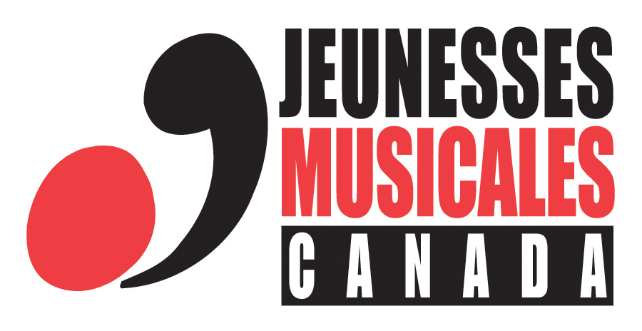
APPLICATION FORM
for the 2016-2017 Young audiences artistic season

Please note that this information will remain confidential.
Insert your photo here
Musician #1 / Contact person Instrument
Last name |  | First name |  |  |  | Mr. Ms.
Address
City |  | Province |  | Postal code
Email
Tel. res. | Cell phone
Date of birth | Age |  | Place of birth
Canadian citizen Permanent resident Other status
Mother tongue |  |  |  |  | Other language(s)
Do you hold a valid driver’s licence Yes No
Highest level of education completed:
Institution |  |  |  | Institution
Diploma received |  |  |  | Diploma received
Currently studying? Yes No – Institution Program
How did you hear about JMC auditions?
I would like to receive information about JMC activities by email.

Insert your photo here
Musician #2 Instrument
Last name | First name |  |  |  | Mr. Ms.
Address
City | Province |  |  | Postal code
Email
Tel. res. | Cell phone
Date of birth | Age |  |  | Place of birth
Canadian citizen Permanent resident Other status
Mother tongue |  |  | Other language(s)
Do you hold a valid driver’s licence Yes No
Highest level of education completed:
Institution |  | Institution
Diploma received |  | Diploma received
Currently studying? Yes No – Institution Program
I would occasionally like to receive information about JMC activities by email.

Musicien #3 Instrument
Insert your photo here
Last name | First name |  |  |  | Mr. Ms.
Address
City | Province |  |  | Postal code
Email
Tel. res. | Cell phone
Date of birth | Age |  |  | Place of birth
Canadian citizen Permanent resident Other status
Mother tongue |  |  | Other language(s)
Do you hold a valid driver’s licence Yes No
Highest level of education completed:
Institution |  | Institution
Diploma received |  | Diploma received
Currently studying? Yes No – Institution Program
I would occasionally like to receive information about JMC activities by email.

Musicien #4 Instrument
Insert your photo here
Last name | First name |  |  |  | Mr. Ms.
Address
City | Province |  |  | Postal code
Email
Tel. res. | Cell phone
Date of birth | Age |  |  | Place of birth
Canadian citizen Permanent resident Other status
Mother tongue |  |  | Other language(s)
Do you hold a valid driver’s licence Yes No
Highest level of education completed:
Institution |  | Institution
Diploma received |  | Diploma received
Currently studying? Yes No – Institution Program
I would occasionally like to receive information about JMC activities by email.

Information on the project and the musicians
Name of the ensemble (if applicable)
Title of the concert
Internet site(s) of the ensemble or musicians

Biographical notes
Musical ensemble (maximum 1,325 characters)

Musician #1 - (maximum 1,325 characters)

Musician #2 - (maximum 1,325 characters)

Musician #3 - (maximum 1,325 characters)

Musician #4 - (maximum 1,325 characters)

